**SQL Operators –** An operator is a symbol that tells the compiles/interpreter to perform specific mathematical , relational, or logical operation to produce a desired result

**What is an Expression :** An expression is a combination of one or more operators and operands which together produce a meaning full result

**Operand :** An operand is an object which is operated upon by any operator to produce a result.

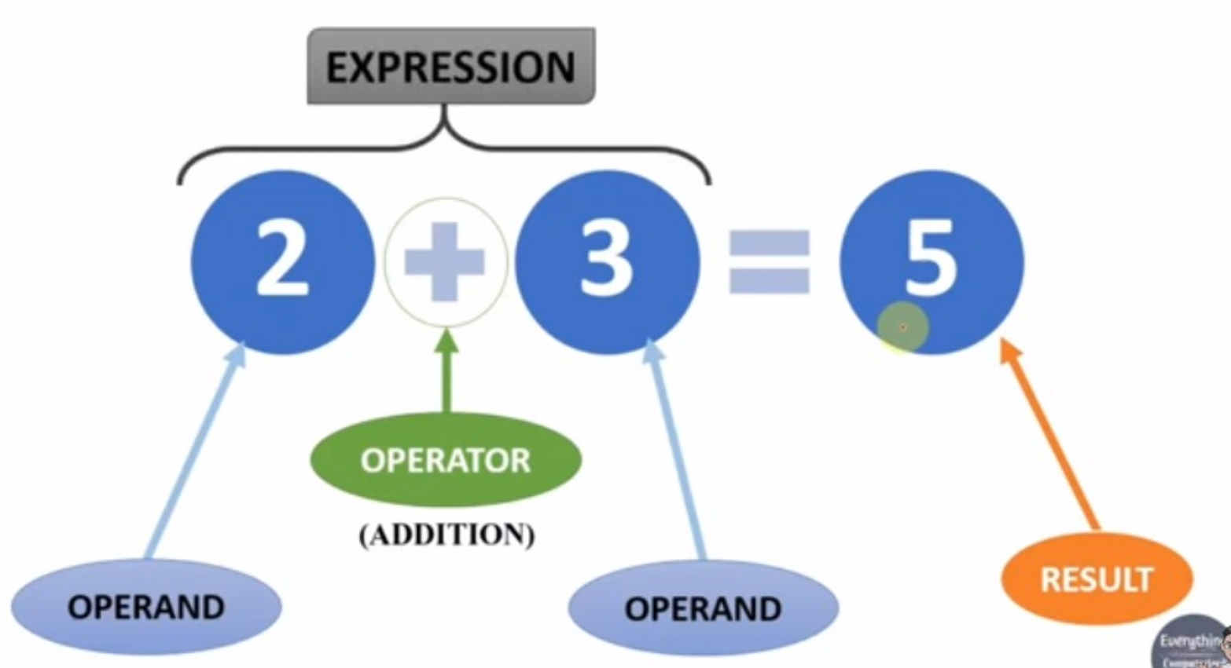

**Types of operators:**

1. **Arithmatic –-- ( +, -, *, /, %)**
2. **Comparison –--( < , > , <= , >= , <> or != , = )**
3. **Bitwise –--------- ( & , | , ^ )**
4. **Logical ----------- ( and , or , like , between , in)**

**Bitwise Operators –** They Compare each bit of the operand to the corresponding bit of the operand and produce final result.

Everything in a computer language is binary, an binary numbers consists of zeroes an ones, these zeroes and ones are knows a bits

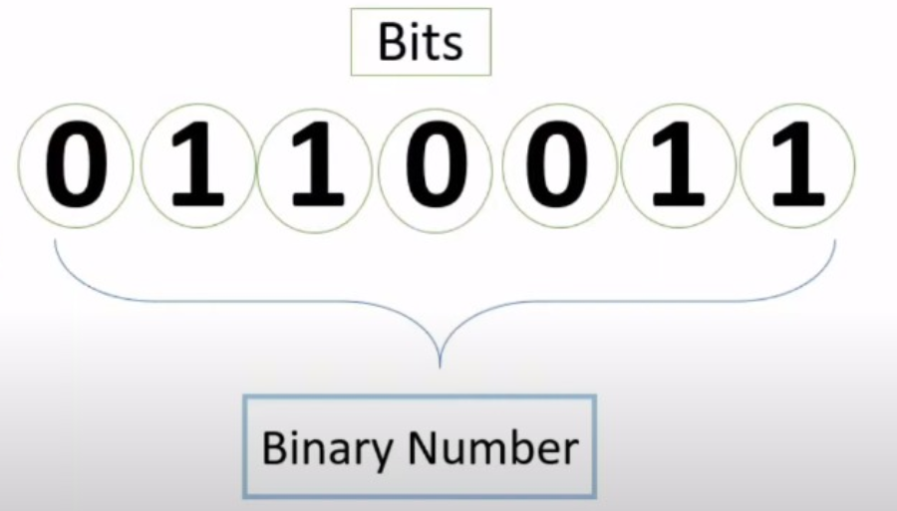

**Working of Bitwise operator**

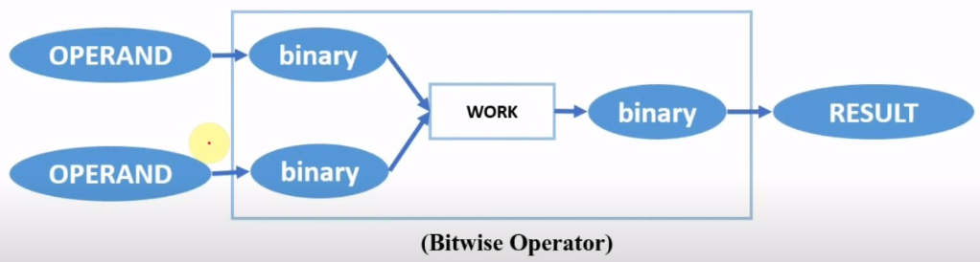

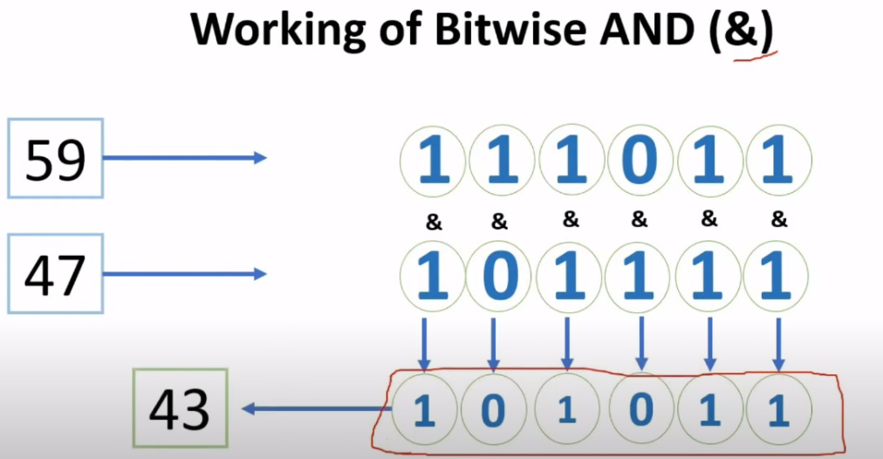

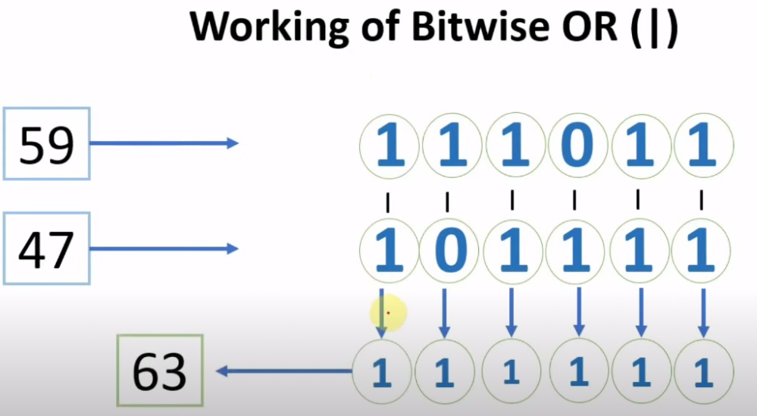

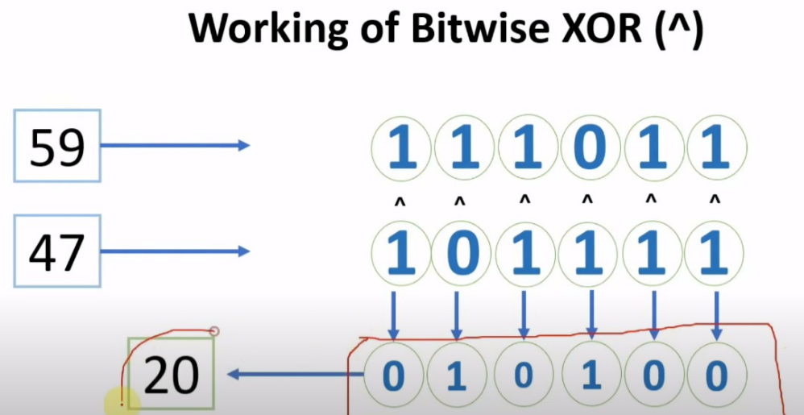

**Logical Operators**

The logical operators connect two or more boolean expressions such that the result of the compound expression depends on the result of the original expression and on the meaning of the operators

-- Results are in True and false

-- AND,OR,NOT,LIKE ('%x'),BETWEEN,IN,ALL,EXIST,ANY,SOME.